**Lab 1: Creating and connecting to AWS EC2 Ubuntu Instance using MobaXterm/PuTTY**

**1.Launch an instance**

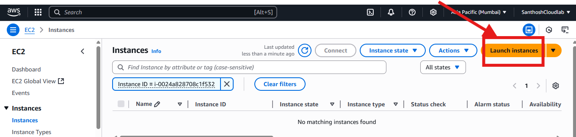

**2. Launch an instance >Name- My-instance1**

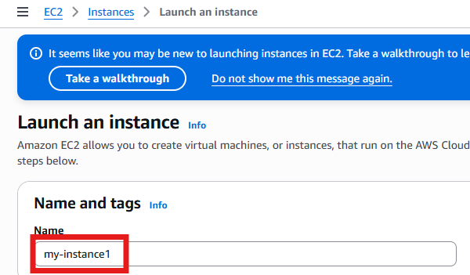

**3.select the Amazon Linux Machine (free tier)> 64 bit Architecture**

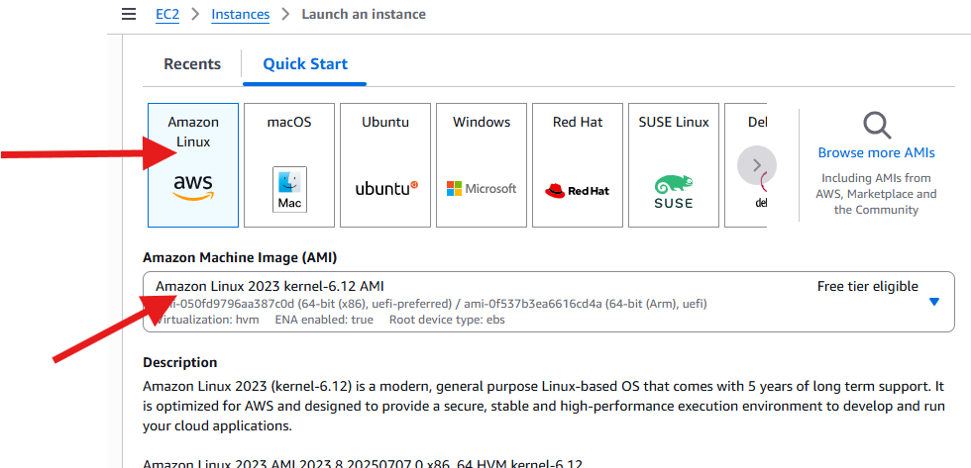

**4.Instance type>** t2.micro

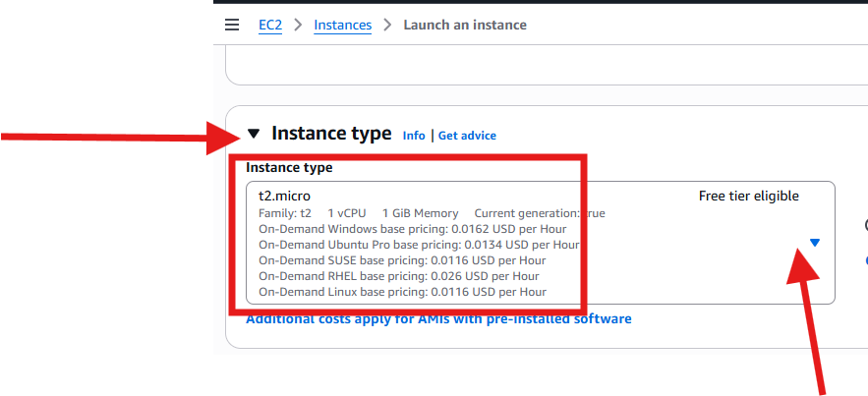

**5.create a new key pair**

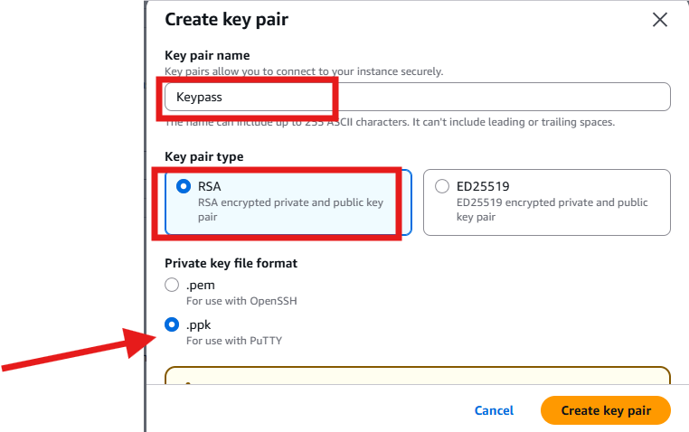

**6. Network settings**

**Default VPC would be selected already**

**Auto-assign public IP should be enabled**

**Firewall (security group) & create a security group & Allow SSH traffic from the internet / Allow Http traffic from the internet both need to be selected**

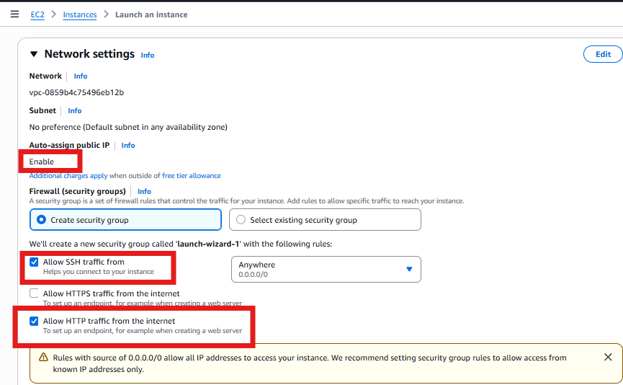

**7.Configure storage- keep it default and launch instance**

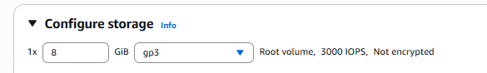

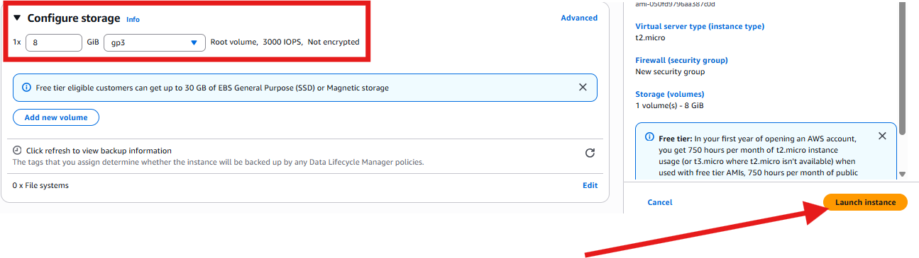

**Connecting the Amazon Linux Machine using MobaXterm**

1. **Download the MobaXterm from online website-** [**https://mobaxterm.mobatek.net/download-home-edition.html**](https://mobaxterm.mobatek.net/download-home-edition.html) **for windows**

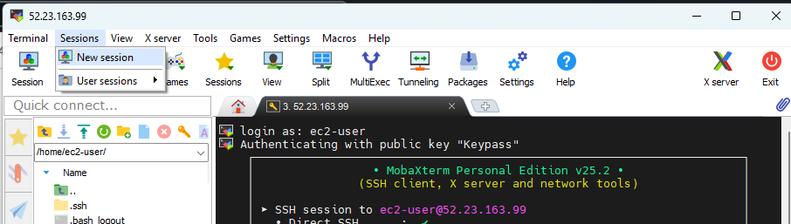

1. **Click on sessions> new session**

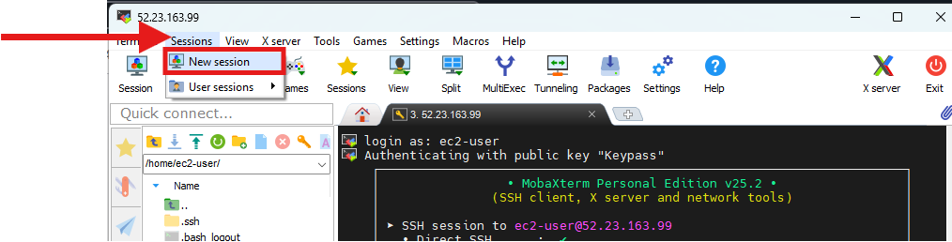

**3.select SSH**

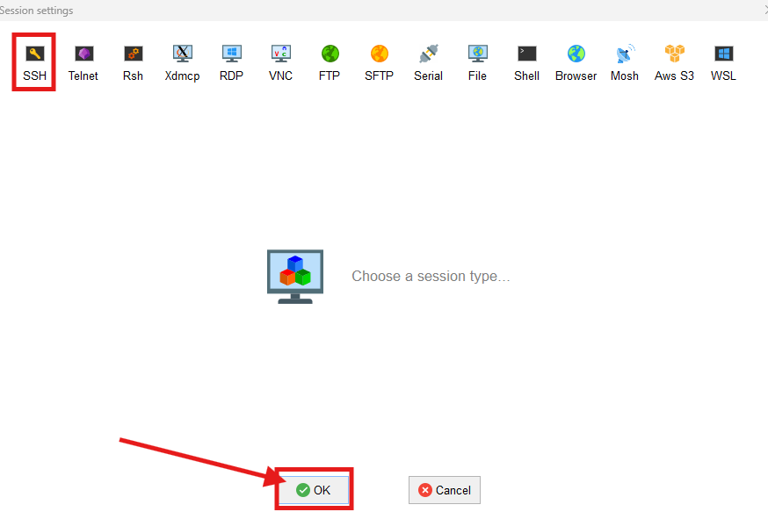

**4.After selecting the SSH > enter the details under Basic SSH setting > Remote host /Enter the user name and then click on Advanced SSH settings**

**Check mark on-Use private key & click on ok**

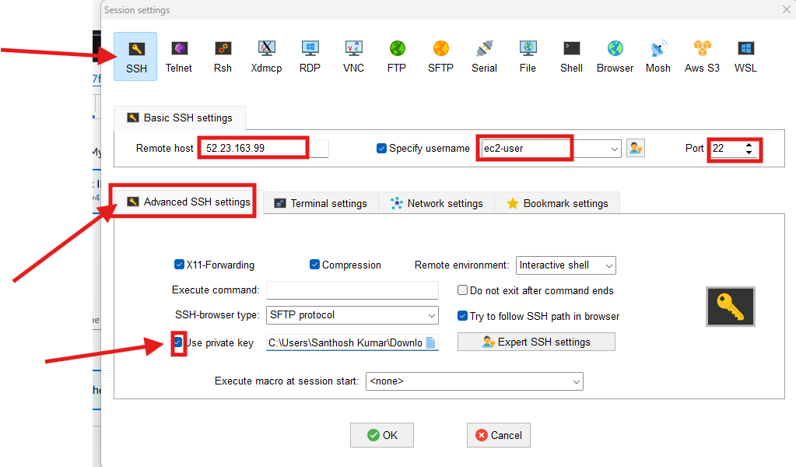

**5. After clicking on OK will see screen like below**

